**CREATING FIRST EC2 INSTANCE USING TERRAFORM**

**STEP1:**CREATE A AN FILE WITH .TF

provider "aws" {

    region = "ap-south-1"  # Set your desired AWS region

}

resource "aws_instance" "example" {

    ami           = "ami-0ad21ae1d0696ad58"  # Specify an appropriate AMI ID

    instance_type = "t2.micro"

    subnet_id="subnet-00d37eec797498ae4"

    key_name="mumbai"

}

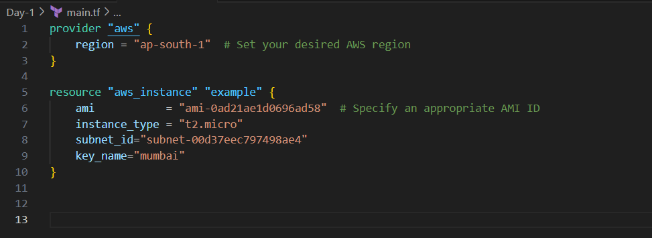

STEP2: Intialize it with **terraform init**

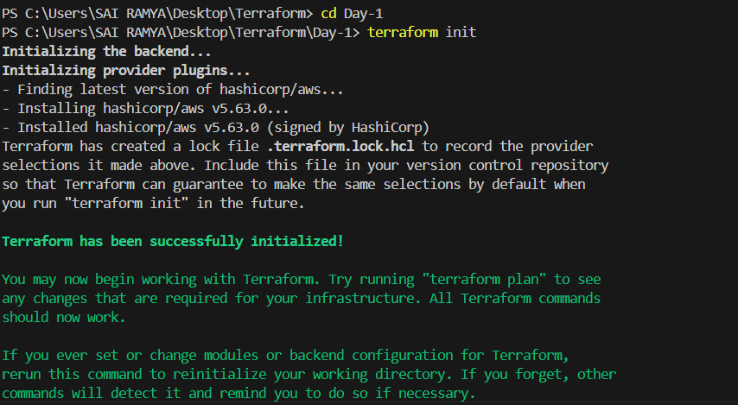

Step3:**terraform plan – It will help us to see what we are are doing before applying**

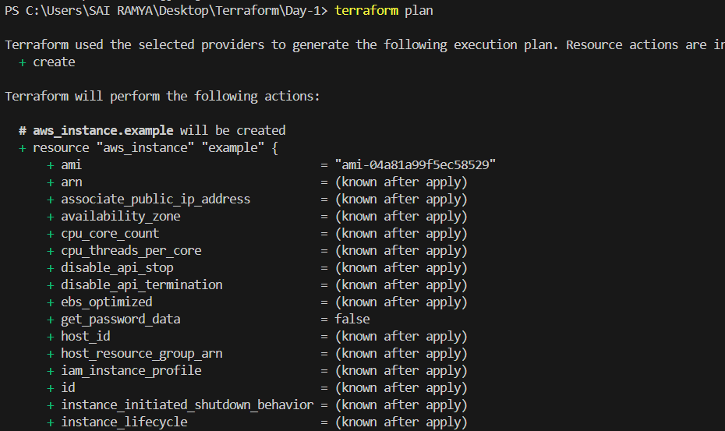

Step4:**terraform apply --Terraform will display a plan of the changes it's going to make. Review the plan and type "yes" when prompted to apply it.**

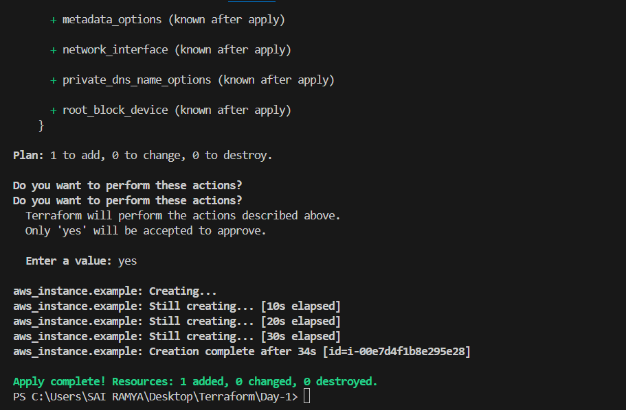



Step5:**terraform destroy --it will delete resources as specified in your Terraform configuration.**

